**contact us**

**inquiry**

**contact us**

**inquiry**

**SHARAD ENGINEERING**

**Categories**

**Autoclaves**

**Heat Exchangers**

**Mixers & Mills**

**Agitators & Stirrers**

**Valves**

**Applications / Special Designs**

**Accessories**

**Process Instrumentation & Automation**

**home**

**about us**

**products**

**services**

**downloads**

***DESIGNERS & MANUFACTURERS OF HIGH PRESSURE LABORATORY REACTORS & PILOT PLANT SYSTEMS***

**AUTOCLAVES**



Non – Stirrer Pressure Vessels

Sizes/Volumes available in the range of 50 ml to 1 litre

Tech Sharad Engineering is the manufacturer of Non Stirred Pressure Vessels

Also Known Acid Digestion Vessels. These vessels are designed to conduct

Research related to corrosion studies of chemicals, acids, liquids, metals,

Storage of liquid or gas, hydrothermal studies, solid state chemical reactions.

Additionally PTFE Liners are also provided on client request.

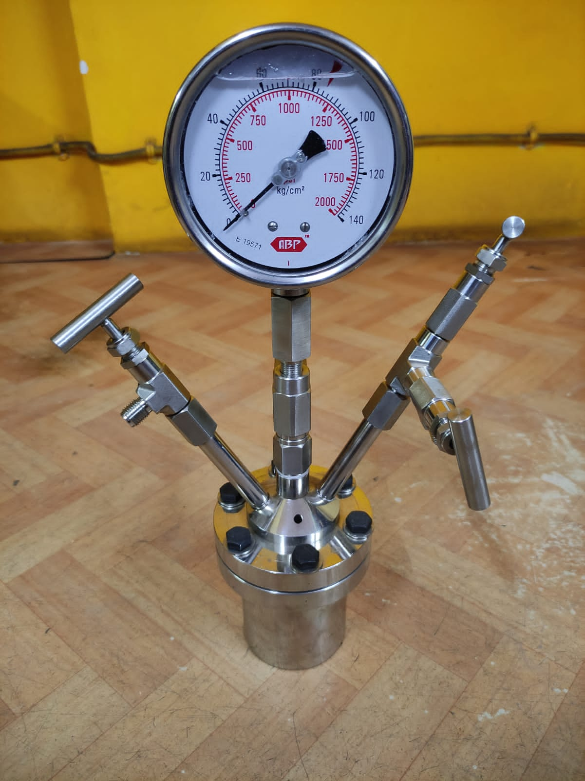

Hydrogenators

Size: 5 Litres - 1000 Litres net filling capacity

MOC: SS-316, SS 316L, Hastelloy B/C, Monel, Inconel, Nickel, Titanium

With Zero leakage magnetic drive coupling from 200-900 kg cm torque

capacity.

Maximum Working Pressure Upto 100 bar & Max. Working Temperature:

350°C .

RPM: 50 - 440 rpm variable speed with geared motors

Body flanges with high tensile bolts & Teflon/spiral wound metallic gaskets

for Shell & dish sealing Offered with SS Jacket or single/double limpet with

insulation & cladding as per requirement

Different Stirrers like Hollow shaft with Gas Induction impeller for Hydrogenation, Pitch blade turbine, Anchor, Helix etc offered as per requirement

Optional accessories like Auto cooling system, Digital pressure indicator, High pressure liquid charging system, Light & sight Glass , Manhole , Condenser, Reflux condenser, Metering pump, Chain pulley , Mass flow controller etc. offered as per requirement

All designs as per ASME codes

